How to Install and Deploy Terraform on Ubuntu
- Update System Packages:
$ sudo apt update && sudo apt upgrade -y
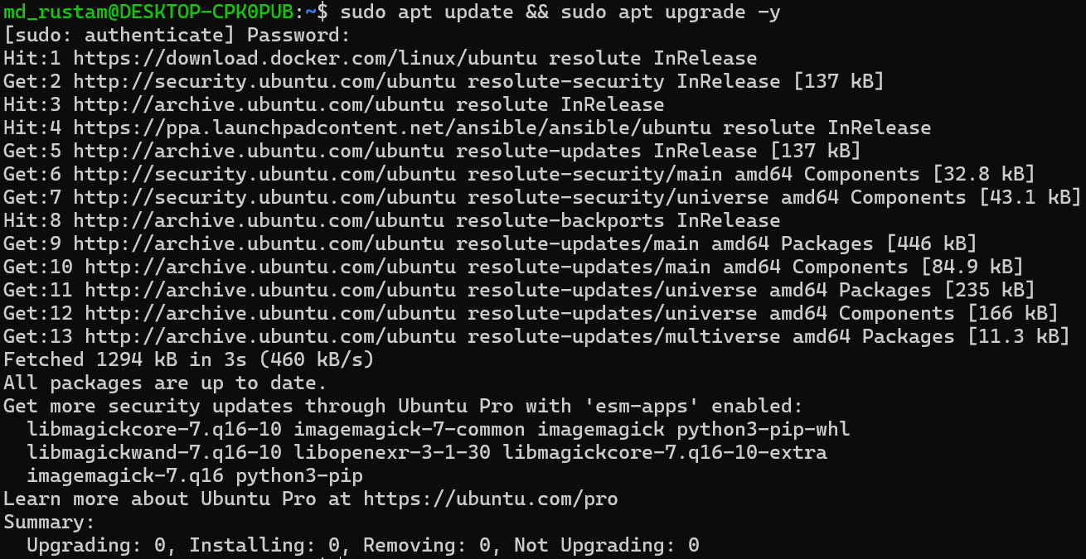
- Install Prerequisites:
$ sudo apt install -y gnupg software-properties-common curl
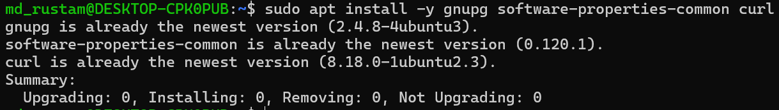

- Add HashiCorp's GPG key and repository:
$ wget -O- https://apt.releases.hashicorp.com/gpg | \
gpg --dearmor | \
$ sudo tee /usr/share/keyrings/hashicorp-archive-keyring.gpg > /dev/null

$ echo "deb [signed-by=/usr/share/keyrings/hashicorp-archive-keyring.gpg]
https://apt.releases.hashicorp.com $(lsb_release -cs) main" | \ sudo tee
/etc/apt/sources.list.d/hashicorp.list
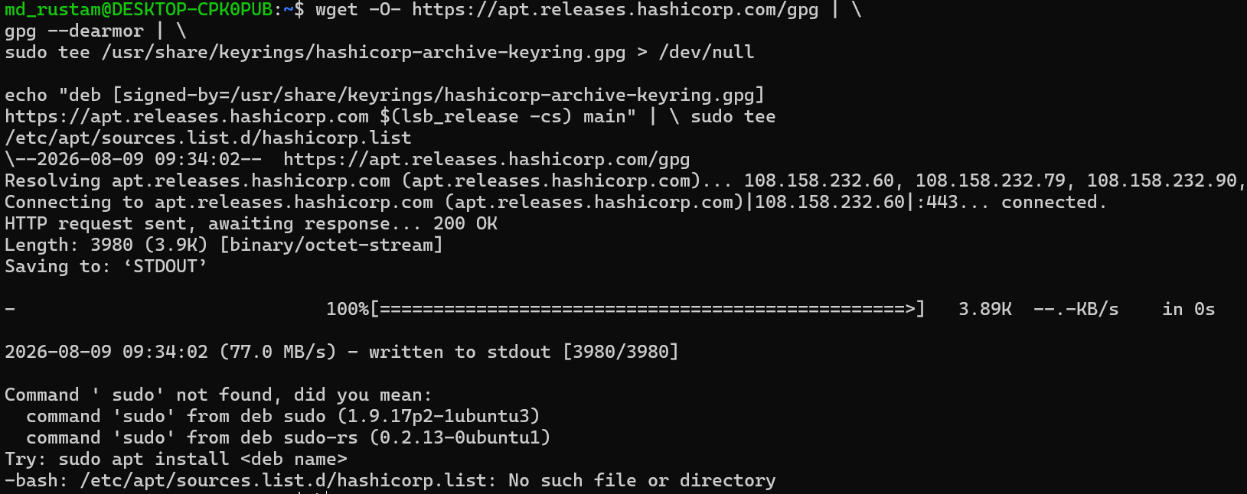
- Install Terraform:
$ sudo apt update
$ sudo apt install terraform

5. Verify the installation:
$ terraform -version
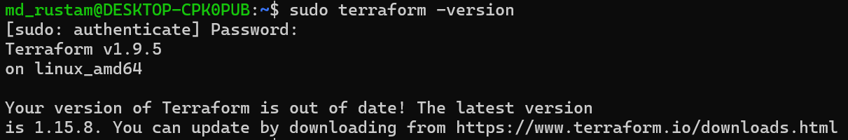
- Set up a working directory and write config:
$ mkdir ~/terraform-project && cd ~/terraform-project
$ vi main.tf

Add your provider and resource blocks (example for AWS):
terraform {
required_providers {
aws = {
source = "hashicorp/aws"
version = "~> 5.0"
}
}
}

provider "aws" {
region = "us-east-1"
}

resource "aws_instance" "example" {
ami = "ami-0abcdef1234567890"
instance_type = "t2.micro"
}

- Initialize, plan, and apply:
$ terraform init # downloads providers/modules
$ terraform validate # checks syntax
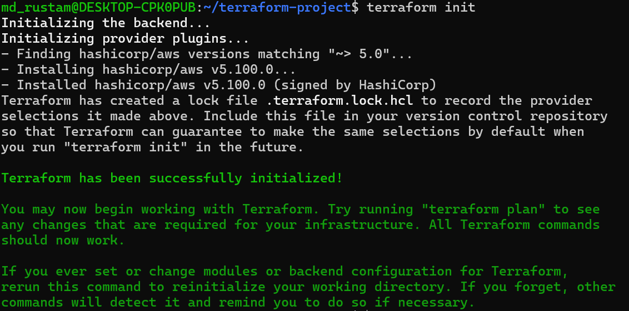
$ terraform plan # shows what will be created/changed
$ terraform apply # applies the changes (type "yes" to confirm)

- Single Terraform configuration that launches Linux EC2 instances in two AWS regions using provider aliases.
$ vi main.tf
terraform {
required_version = ">= 1.5.0"
required_providers {
aws = {
source = "hashicorp/aws"
version = "~> 5.0"
}
}
}

# Providers for two regions
# ---------------------------
provider "aws" {
alias = "region1"
region = "us-east-1"
}

provider "aws" {
alias = "region2"
region = "eu-west-1"
}

# Latest Amazon Linux 2023 AMI - Region 1

data "aws_ami" "al2023_region1" {
provider = aws.region1
most_recent = true
owners = ["amazon"]

filter {
name = "name"
values = ["al2023-ami-*-x86_64"]
}

filter {
name = "virtualization-type"
values = ["hvm"]
}
}

# Latest Amazon Linux 2023 AMI - Region 2

data "aws_ami" "al2023_region2" {
provider = aws.region2
most_recent = true
owners = ["amazon"]

filter {
name = "name"
values = ["al2023-ami-*-x86_64"]
}

filter {
name = "virtualization-type"
values = ["hvm"]
}
}

# EC2 Instance - Region 1 (us-east-1)

resource "aws_instance" "instance_region1" {
provider = aws.region1
ami = data.aws_ami.al2023_region1.id
instance_type = var.instance_type

tags = {
Name = "instance-us-east-1"
}
}

# EC2 Instance - Region 2 (eu-west-1)

resource "aws_instance" "instance_region2" {
provider = aws.region2
ami = data.aws_ami.al2023_region2.id
instance_type = var.instance_type

tags = {
Name = "instance-eu-west-1"
}
}

# Variables

variable "instance_type" {
description = "EC2 instance type"
type = string
default = "t2.micro"
}

# Outputs

output "region1_instance_id" {
value = aws_instance.instance_region1.id
}

output "region1_public_ip" {
value = aws_instance.instance_region1.public_ip
}

output "region2_instance_id" {
value = aws_instance.instance_region2.id
}

output "region2_public_ip" {
value = aws_instance.instance_region2.public_ip
}

- Deployment steps:
# 1. Set up AWS credentials (if not already configured)
aws configure

# 2. Initialize Terraform (downloads AWS provider)
terraform init

# 3. Validate syntax
terraform validate

# 4. Preview the changes
terraform plan

# 5. Apply — creates instances in both regions
terraform apply

